Sumama Rahim
F24BSCS039
Database systems Lab 02 Task Report

Name | Sumama Rahim | Course | Database Systems (CSC-103) | Dprtt/ Program | IET - BSCS
Registration | F24BSCS039 | Instructor | Dr. M. Bilal Shahnawaz | Date | 03/15/2025

Lab 02 Task Report

Problem: Write a report to show the applied queries and their responses.
Solution:

Query 1. Show all of the inserted records of Employees.

-- 1. Showing all the inserted record --
SELECT *
FROM Employee;

Response:
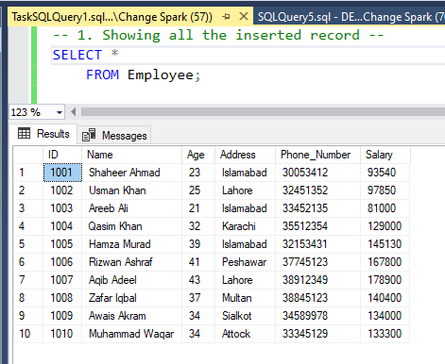

Query 2. Show employees and their salaries.

-- 2. Showing Employees with their salaries --
SELECT Name, Salary
FROM Employee;

Response:
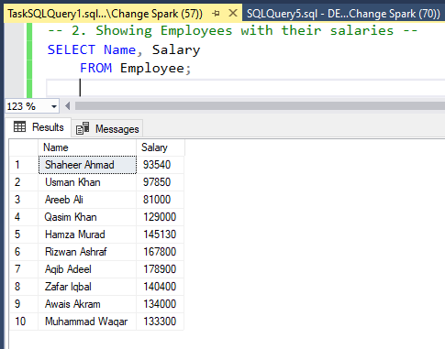

Query 3. Show all distinct cities of the employees.
-- 3. Showing all distinct cities of the Employees --
SELECT DISTINCT City
FROM Employee;
Response:
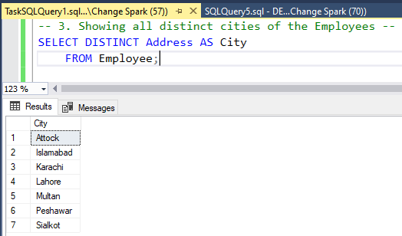

Query 4. Show the salary of employees as updated_Salary, if each employee gets an increment of 10,000.

-- 4. Showing the salary of employees as updated_Salary, if each employee gets an increment of 10,000 --
SELECT ID, Name, Salary, (Salary+10000) AS updated_Salary
FROM Employee;

Response:
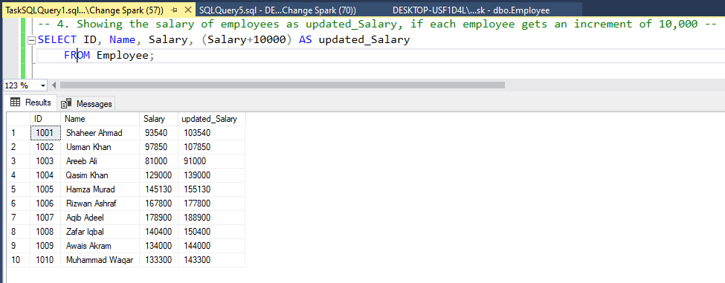

Query 5. Show the salary of employees as Payable_Salary, if a new tax of 20% is imposed on the current salary.

-- 5. Showing the salary of employees as Payable_Salary, if a new tax of 20% is imposed on current salary --
SELECT ID, Name, Salary, (Salary-(20*Salary/100)) AS Payable_Salary
-- OR (Salary-(0.2*Salary) AS Payable_Salary --
FROM Employee;

Response 1:

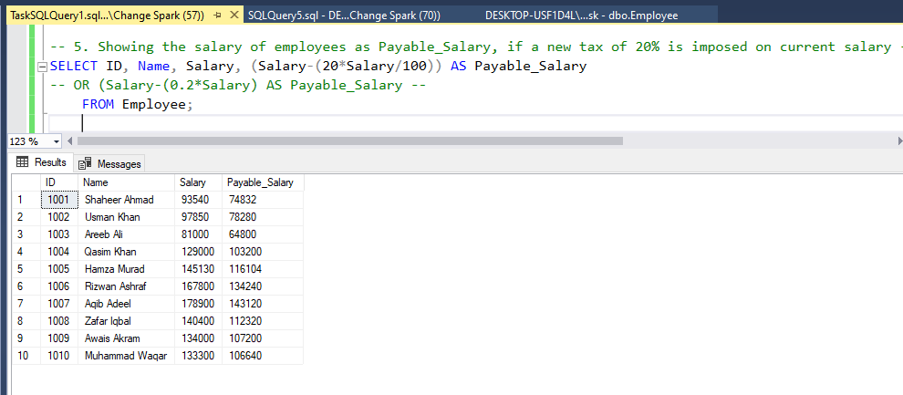

-- Merger of 4 and 5 Point --
-- 5. Showing the salary of employees as Payable_Salary, if a new tax of 20% is imposed on current salary --
SELECT ID, Name, Salary AS previuos_Salary, Salary+10000 AS updated_Salary, ((Salary+10000)-(0.2*(Salary+10000))) AS Payable_Salary
FROM Employee;

Response 2:
